PUMA HYPNOTIC SANDAL
PRICE: Approximately Rs. 5,999
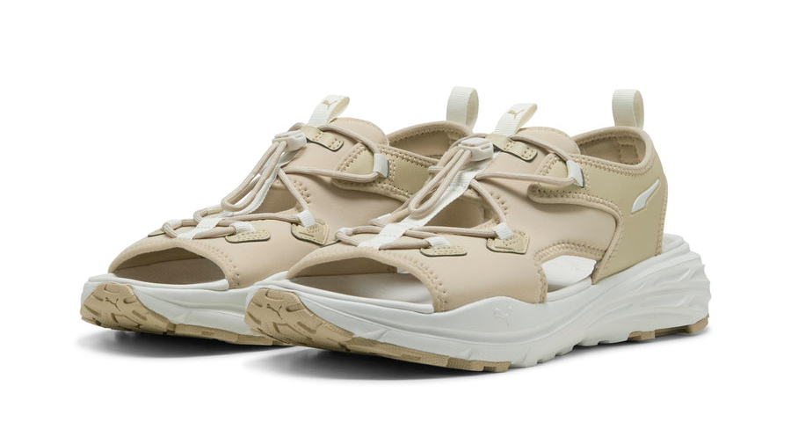
_{Introduction:}
The Puma Hypnotic Sandal is a modern and comfortable footwear option designed for everyday wear, casual outings, and light activities. Built with a focus on ease, breathability, and style, this sandal offers a relaxed fit while maintaining a sporty and contemporary look. Its cushioned foot bed provides all-day comfort, making it ideal for warm weather and extended wear. Whether you’re heading out for errands, travel, or casual use, the Puma Hypnotic Sandal delivers reliable comfort and durability with the trusted quality of Puma.
Product Overview:
The Puma Hypnotic Sandal is designed to provide comfort and convenience with a slip-on style and adjustable straps for a secure fit. Its lightweight construction ensures ease of movement, while the cushioned sole helps reduce foot fatigue during daily use.
About the Brand:

Puma is a globally recognized sports and lifestyle brand known for combining performance, innovation, and modern design. Puma footwear is trusted worldwide for its comfort, durability, suitable for both athletic and casual wear.

Key Features:
- Iconic design inspired by Allen Iverson’s signature style
- Cushioned foot bed for all-day comfort
- Adjustable straps for a secure fit
- Lightweight and breathable design
- Durable outsole for everyday use
- Modern sporty appearance with Puma branding

Design & Build Quality:
The Puma Hypnotic Sandal features a clean and ergonomic design that supports natural foot movement. Its sturdy strap construction and quality stitching ensure durability, while the contoured sole enhances comfort and stability during wear.
Storage & Capacity:
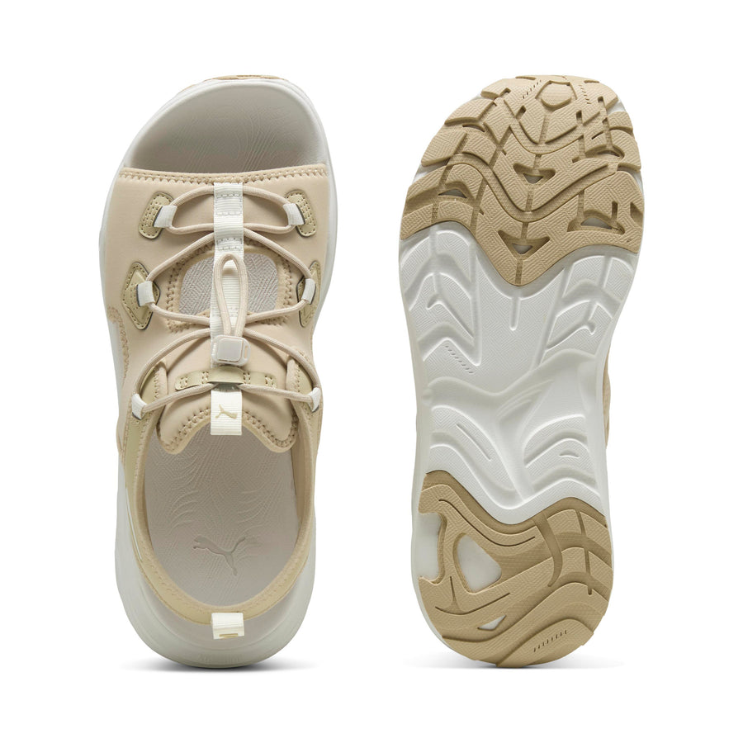
The sandal’s lightweight and compact design makes it easy to store in shoe racks, travel bags, or luggage. It requires minimal space and is convenient for daily use, travel, or casual outings.

Material & Durability:
Constructed from high-quality synthetic materials, the Puma Hypnotic Sandal is designed to withstand regular wear. The materials are resistant to everyday wear and provide long-lasting comfort and structural integrity.
Ideal For:
- Casual daily wear
- Warm-weather use
- Travel and short outings
- Users seeking comfort-focused sandals
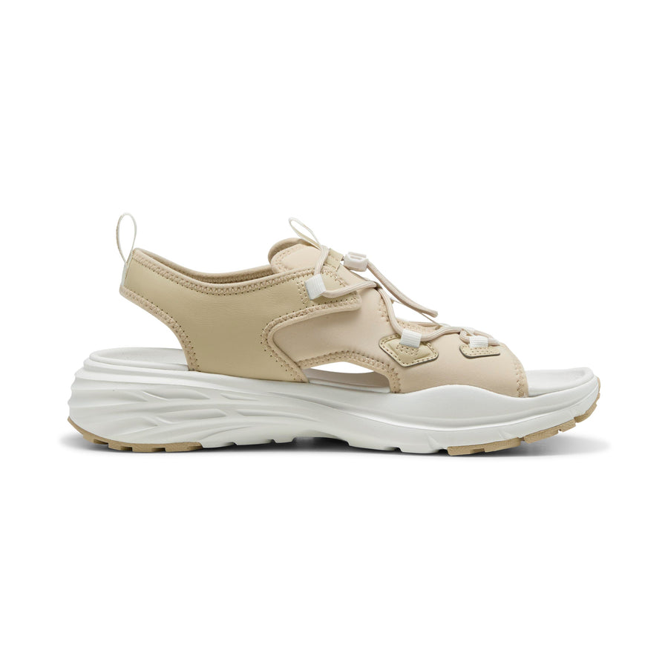

Care Instructions:
- Wipe clean with a damp cloth
- Do not machine wash
- Air dry away from direct sunlight
- Store in a dry place when not in use
Product Specifications:
- Brand: Puma
- Model: Hypnotic Sandal
- Product Type: Casual Sandal
- Upper Material: Synthetic
- Foot bed: Cushioned
- Outsole: Durable rubber
- Closure: Adjustable straps
- Sizes Available: UK 6–11 (approx.)
Product Summary:
The Puma Hypnotic Sandal offers a perfect balance of comfort, style, and durability for everyday wear. With its cushioned sole, adjustable fit, and lightweight design, it is a practical choice for casual and warm-weather use.

